**Functional Requirements Document**

**The Blaugranes**

**UofR Student Hub**

**01/11/2019**

**Ufuoma Aya**

**Anirudh Bindal**

**Kyle Jakob Labatete**

**Sopuruchukwu Gift Ugwuonah**

|  |  |  |  |
| --- | --- | --- | --- |
| **Version** | **Description of Change** | **Author** | **Date** |
| 1 |  | Ufuoma Aya | 01/11/2019 |
|  |  |  |  |

**CONTENTS**

1 INTRODUCTION 4

1.1 Purpose 4

1.2 Scope 4

1.3 Background 4

1.4 References 4

1.5 Assumptions and Constraints 4

1.6 Document Overview 5

2 METHODOLOGY 5

3 FUNCTIONAL REQUIREMENTS 5

4.1 Context 5

4.2 User Requirements 5

4.3 Data Flow Diagrams 6

4.4 Logical Data Model/Data Dictionary 6

4.5 Functional Requirements 6

5 OTHER REQUIREMENTS 6

5.1 Interface Requirements 6

5.2 Data Conversion Requirements 7

5.3 Hardware/Software Requirements 7

5.4 Operational Requirements 7

APPENDIX A - GLOSSARY 11

1. **INTRODUCTION**

## **Purpose**

The purpose of UofR Student Hub website is to provide a safe and educative platform where students who are currently enrolled in a program at the University of Regina can learn and exchange knowledge in an interactive and fun approach.

This document will provide detailed information on the functional requirements available to accomplish this task. Discussions on the architectural approach will be provided. Also, it will provide guidelines on the procedures needed to be taken to ensure a successful functional website.

## **Scope**

This document will help the team and users have a better understanding on the functionalities of our website. It will provide clear details of what is needed for the website to work, the processes and measures implemented that makes the website work and functionalities of the website.

This is achieved by comprehensively detailing the several needs of our website and providing a process of solving these needs. To improve the quality and functionalities of our website, modifications will be implemented, therefore, our website is subjected to changes in the nearest future.

## **Background**

We are a team of four, collectively known as The Blaugranes. The members are Ufuoma Aya, Anirudh Bindal, Kyle Jakob Labatete and Sopuruchukwu Gift Ugwuonah. It is our commitment to design and develop a website or minimum viable product (login, registration and department webpages) before the intended due date. As such, we have divided the development process to achieving this goal and each member has been assigned to a particular task.

This document will provide useful and necessary information needed to help understand the project’s scope and architecture.

## **References**

<https://github.com/Blaugranes/UofR-Student-Hub/tree/master/UML>

<https://github.com/Blaugranes/UofR-Student-Hub/blob/master/Lo-Fidelity%20Prototype.pdf>

<https://github.com/Blaugranes/UofR-Student-Hub/blob/master/MVC%20-%20MileStone%202.pptx>

<https://github.com/Blaugranes/UofR-Student-Hub/projects/1>

## **Assumptions and Constraints**

### **Assumptions**

This document assumes that required users are students are currently enrolled in a program at the University of Regina.

### **Constraints**

Constraints are boundary conditions on how the system must be designed and constructed. Examples include: legal requirements, technical standards, strategic decisions.

* Constraints exist because of real business conditions. For example, a delivery date is a constraint only if there are real business consequences that will happen as a result of not meeting the date. If failing to have the subject application operational by the specified date places the organization in legal default, the date is a constraint.
* Preferences are arbitrary. For example, a date chosen arbitrarily is a preference. Preferences, if included in the FRD, should be noted as such.]

## **Document Overview**

This document will provide a clarifying explanation on the current processes, plans, architectural designs, requirements and limitations of the development of our website . It will contain discussions of what the functional requirements are, the processes and measures taken, the implementation of architectural designs and correlations to the project. Also, we will detail the guiding principles and importance behind our website’s security and privacy, audit trail, reliability, recoverability, and error handling as well as other needs such as supported interfaces and hardwares.

1. **METHODOLOGY**

Problems may arise in the development process of our website, the team will brainstorm and develop solutions to deal with these problems. The solutions will be implemented, therefore, continuously implementing modifications will to our website. This document will also outline modifications implemented for the improvement of already existing functionalities and addition of new functionalities.

1. **FUNCTIONAL REQUIREMENTS**

## **Context**

[Provide a context diagram of the system, with explanations as applicable. The context of a system refers to the connections and relationships between the system and its environment.]

**Exhibit 2 - Generic Context Diagram**

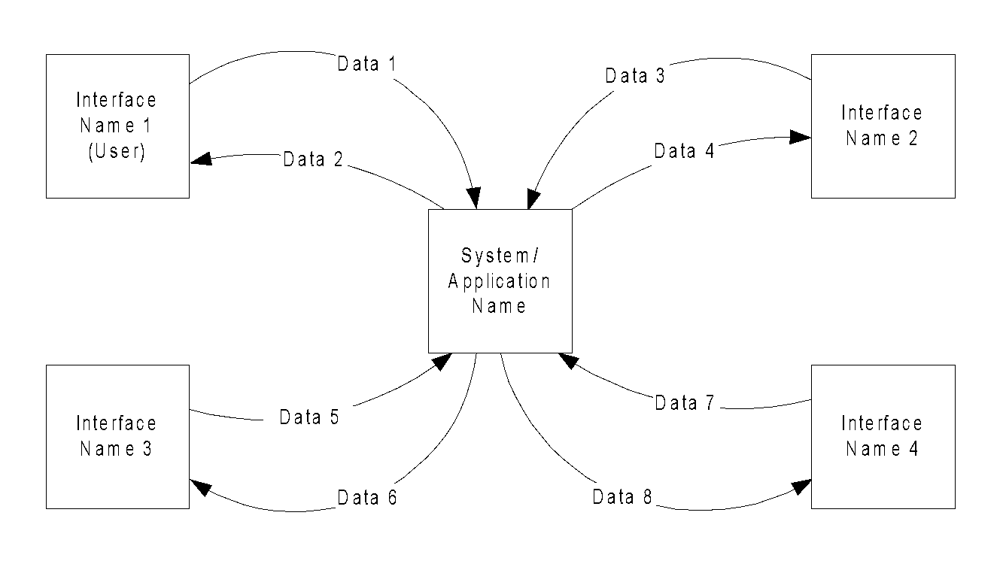

## **User Requirements**

Our website is only valid for students currently enrolled in a program at the University of Regina. User should be able to create discussion threads, comment and vote on already existing discussion threads.

Users should be able to access the general university’s public page, the page of their respective department and also, be able to view upcoming events on the general public and department pages.

Users should be able to receive notifications, these notifications should result from one of the following: a new discussion thread added on the department page, a new comment added to a discussion thread being followed by the user, a vote added casted on a discussion thread or comment and an upcoming event.

For minimum viable product, users should be able to access the registration webpage and will be required to provide necessary information (including their respective departments) to successfully register to the website. After registration is completed, users should be able to successfully login to the website to gain access to the public page and their respective department page.

## **Data Flow Diagrams**

[Decompose the context level diagrams to determine the functional requirements. Data flow diagrams should be decomposed down to the functional primitive level. These diagrams are further decomposed during design.]

## **Logical Data Model/Data Dictionary**

Class diagram is subjected to modifications in the future.

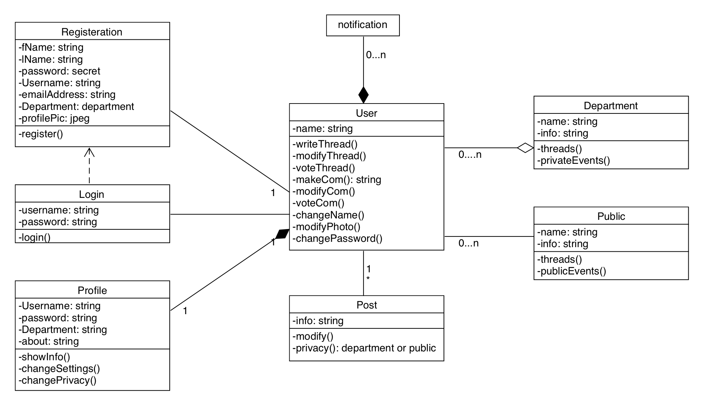

## **Functional Requirements**

### **Functional Requirements Group 1**

[List the functional requirements for each functional requirements group.]

**Exhibit 4 - Sample Requirements Group 1**

|  |  |
| --- | --- |
| **Section/ Requirement ID** | **Requirement Definition** |
| FR1.0. | The system shall [parent requirement group 1]. |
| FR1.1 | The system shall [child/parent requirement]. |
| FR1.1.1 | The system shall [child requirement]. |
| FR1.1.2 | The system shall [child requirement]. |

### **Functional Requirements Group 2, Etc.**

1. **OTHER REQUIREMENTS**

## **Interface Requirements**

Users should be able to interface with the website via a supported web browser.

### **Hardware Interfaces**

Several tests have been carried out on both computers and mobile devices. Although these devices should be able to interface with our website via supported web browsers, the mobile version needs to be modified to be fully compatible with several screen sizes.

### **Software Interfaces**

[Name the applications with which the subject application must interface. State the following for each such application: name of application, external owner of application, interface details (only if determined by the other application).

It is acceptable to reference an interface control document for details of the interface interactions.]

### **Communications Interfaces**

[Describe communications interfaces to other systems or devices, such as local area networks.]

## **Data Conversion Requirements**

[Describe the requirements needed for conversion of legacy data into the system.]

## **Hardware/Software Requirements**

[Provide a description of the hardware and software platforms needed to support the system.]

## **Operational Requirements**

### **Security and Privacy**

A. Consequences of the following breaches of security in the subject application:

1. Loss or corruption of data

* Minimal consequences expected. No breaches in privacy.

1. Disclosure of secrets or sensitive information

* No foreseeable reason for users’ personal information to be disclosed to attackers.

1. Disclosure of privileged/privacy information about individuals

* No foreseeable reason for users private information to be disclosed to external sources such as hackers.

1. Corruption of software or introduction of malware, such as viruses

* We will ensure the inability of external sources such as hackers to gain control of our website.

1. State the type(s) of security required. Include the need for the following as appropriate:
2. Access by user role or types.

* Required username and protected password

1. State access control requirements by data attribute. For example, one group of users has permission to view an attribute but not update it while another group of users has permissions to update or view it.
2. State access requirements based on system function. For example, if there is a need to grant access to certain system functions to one group of users, but not to another. For example, "The system shall make Function X available to the System Administrator only".
3. State if there is a need for certification and accreditation of the security measures adopted for this application]

*The Security Section describes the need to control access to the data. This includes controlling who may view and alter application data.*

### **Audit Trail**

[List the activities recorded in the application’s audit trail. For each activity, list the data recorded.]

### **Reliability**

If there exists a performance failure in our website, we will define the cause and work on developing a solution. Users should able to lookup and access alternative solutions.

### **Recoverability**

[Answer the following questions in this section:

A. In the event the application is unavailable to users (down) because of a system failure, how soon after the failure is detected must function be restored?

B. In the event the database is corrupted, to what level of currency must it be restored? For example “The database must be capable of being restored to its condition of no more than 1 hour before the corruption occurred”.

C. If the processing site (hardware, data, and onsite backup) is destroyed, how soon must the application be able to be restored?]

*Recoverability is the ability to restore function and data in the event of a failure.*

### **System Availability**

[State the period during which the application must be available to users. For example, “*The application must be available to users Monday through Friday between the hours of 6:30 a.m. and 5:30 p.m. EST.* If the application must be available to users in more than one time zone, state the earliest start time and the latest stop time. Consider daylight savings time, too.

Include use peak times. These are times when system unavailability is least acceptable.]

*System availability is the time when the application must be available for use. Required system availability is used in determining when maintenance may be performed.*

### **General Performance**

[Describe the requirements for the following:

A. Response time for queries and updates

B. Throughput

C. Expected rate of user activity (for example, number of transactions per hour, day, or month, or cyclical periods)

Specific performance requirements, related to a specific functional requirement, should be listed with that functional requirement.

### **Capacity**

[List the required capacities and expected volumes of data in business terms. Do not state capacities in terms of system memory requirements or disk space—if growth trends or projections are available, provide them]

### **Data Retention**

[Describe the length of time various forms of data must be retained and the requirements for its destruction.

For example, “The system shall retain application information for 3 years”. Different forms of data include: system documentation, audit records, database records, access records.]

### **Error Handling**

[Describe system error handling.]

### **Validation Rules**

[Describe System Validation Rules.]

### **Conventions/Standards**

[Describe system conventions and standards followed.

For example: Microsoft standards are followed for windows, Institute of Electrical and Electronics Engineers (IEEE) for data formats, etc.]

**APPENDIX A - GLOSSARY**

[Define terms, acronyms, and abbreviations used in the FRD.]